REGISTER FOR THE CHEERLEADING PROGRAM!!

About the MCOC Cheer Program
The Mallard Creek Optimist Club Cheer Program is designed to build self-confidence, emphasizes basic cheerleading skills, and demonstrates the importance of teamwork, good sportsmanship, and the significance of being part of a cheer squad. Cheerleaders will be taught in a low-pressure, safe and fun environment as they learn proper cheerleading techniques that challenge all girls from beginner to advanced levels. Participants will focus on stunting, basic tumbling, jumps, cheers and chants, as well as learn spirit dance routines. Squads will be created based on the age of cheerleaders in order for the team to learn cheers and routines that are appropriate for their age and skill level. All girls, ages 5 and up, are invited to join the MCOC Cheer Program, regardless of previous cheerleading experience or ability. Sign up today!
MCOC Pop Warner Cheerleading Program – Football Season (August – November)
Participants will cheer at weekly football games for our Mallard Creek Chargers Football Teams! Cheerleaders will keep the crowd’s enthusiasm up, cheer the Chargers on to victory, and showcase their talents with a choreographed half-time routine. Cheerleaders will also learn a competitive cheer and dance routine, and the squads will head to a local Pop Warner Cheerleading Competition near the end of the season. There is even a chance to compete at a National Pop Warner Cheerleading Competition at Disney World in Florida (please ask for details).
The MCOC Basketball Cheerleading Program runs from November – March
MCOC Cheer Program Highlights
- Develop cheerleading skills
- Possibility of performing at a Pop Warner Cheer Competition (Football season only)
- Receive an official Mallard Creek Optimist Club Cheerleading Uniform
- Build self-esteem and character
- Make new friends
- Show your MCOC Cheer pride and HAVE FUN!!
Cheerleading Qualifications
- All cheerleaders must be at least 5 years of age in order to participate
- All MCOC Cheer registration paperwork must be completed and returned with payment
- Previous cheerleading / dance experience is NOT required. All skill levels are accepted and welcome to join our Cheer Program!
What’s Included
The MCOC Cheer Program is full of fun, energy, cheerleading, and teamwork! All cheerleaders will receive the official MCOC Cheerleading Uniform that includes a cheer top, cheer skirt, a hair bow, socks, and pompoms. At the end of the season MCOC Cheer Banquet, cheerleaders will be awarded a certificate of completion along with a gift.
For More Information
- Please contact Rekia Lipscomb, the MCOC Cheer Commissioner at MCOCcheerleading@outlook.com
- You may visit us on the web at www.MallardCreekOptimistClub.com
- Check us out on Facebook at Mallard Creek Optimist Club

The Registration Form is on the back of this Information Sheet for your convenience
Registration Form Cheerleading
$300.00
Please circle the Cheer Program you are signing up for: Football or Basketball
Name of Cheerleader: ________________________________________________________________________________________________________________
Age: __________________________Date of Birth: ______________________________________Grade in School: ____________________________________
Address: __________________________________________________________________________________________________________________________
Parent/Guardian Name: ____________________________________________________Parent/Guardian E-mail: _______________________________________
Parent/Guardian Phone Number: ________________________________________Parent/Guardian Alt. Phone Number: _________________________________
Emergency Contact: ____________________________________________________Emergency Contact Phone Number: ____________________________________
*** Selecting the appropriate uniform size is the Parent/Guardian responsibility, please see below on how to properly measure for the best uniform fit ***
- Please Circle The Requested Uniform Size Below -
Chest: Measure around the fullest part of the chest
Waist: Measure around the waist, right below the belly button (not over shirts or slacks)
Hips: Measure around the body at the fullest part of the hips
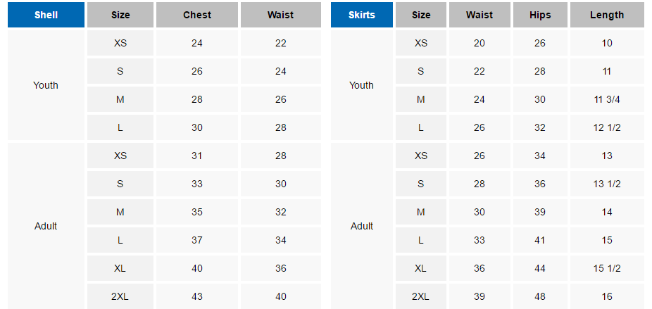
Please make checks payable to Mallard Creek Optimist Club. $25 dollars of the Registration fee is non-refundable to cover administration costs. 50% of the registration fee is non-refundable once teams have been selected and uniforms ordered.
Legal Permission to Cheer:
This herby certifies that I, the parent or legal guardian of the above-named participant, grant permission for them to participate in any and all cheerleading activities during the above listed Cheerleading season. I hereby authorize the adult manage/coach to obtain medical care from any licensed physician, hospital or medical clinic for the above-named participant at such times that the paret or legal guardian cannot be contacted in person or by telephone. This authorization includes all program activities, and I do hereby waive, release, absolve, indemnify and agree to hold harmless the local league, mallard Creek Optimist Club, the organizers, supervisors, participants and persons transporting the participant to and from those activities for any claim arising out of any injury to participant or for any other claim or action arising out of negligence or otherwise, except to the extent and in the amount covered by accident/liability isnurance.
Parent/Guardian Signature: ______________________________________________________________________Date: _________________________________* Mail Form to Mallard Creek Optimist Club: 8611 Concord Mills Blvd. #458 Concord, NC 28027 or scan form via e-mail to MCOCcheerleading@outlook.com**

