Mallard Creek Optimist Club Member Application

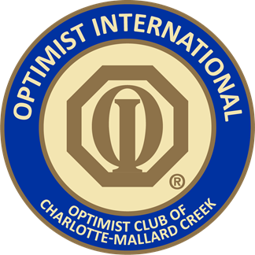

Annual Dues
New Members – $100 per person
Returning Members - $85 per person
Under Thirty Years Old $30.00 a person
Active College Students: $23.00

Name_______________________________ _______________________________________________

Address______________________________City___________________State___________Zip______

Phone # Home_______________________________Cell_____________________________________

Email_______________________________________________________________________________

Birthdate________________

Sponsor (club member who recommended you) ___________________________________________

All children in family, up to age 18 (still in school) are automatically enrolled in our Jr. Optimist Program.

We meet monthly (every 3rd Sunday) 6:30pm at Dave & Busters at Concord Mills, Concord NC.
***Buffet is FREE to all adult members at monthly meetings.***
Children can eat off the buffet for $5.00 each or can order off the menu at your cost.

Mail your application and payment to:
MCOC: c/o
8611 Concord Mills Blvd. #458 Concord, NC 28027
Mission Statement:
By Providing Hope and Positive Vision, Optimists bring out the Best in Kids,
The Communities and Themselves.

